Introduction to 1C coding
The 1C:Enterprise script is a domain-specific programming language specifically designed for both professional programmers and users. The code in 1C Enterprise script is stored in modules. Almost every configuration object in 1C has a module (some objects may have several). The object module structure can have three areas:
- variable declaration area
- procedure and function area
- main program area
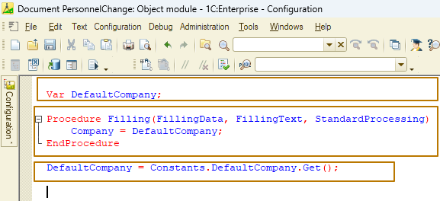
However, none of the areas is mandatory and may be missing in a particular module. Common modules may have only procedure and function area.
Each individual program module is a part of the configuration and cannot exist separately from it. All code within a module is executed in a single context. We will talk more about modules in one of the next lessons.
Variable, procedure and function names may consist of any sequence of letters, digits and underline symbols "_", beginning with a letter or with underline symbol "_".
New names cannot be the same as reserved language words or as names of properties that are directly available in the current context. Variable, procedure and function names are not case sensitive.
Comments
A comment in the code starts after the characters “//” and ends at the end of the line:
Factor = 10; // This is a comment
// And this is a comment
This is not a comment

Reserved words
The following keywords are reserved and cannot be used as generated variable names, attributes of configuration objects, and declared procedures and functions
Reserved keywords
If | And | New
Then | Or | Execute
ElsIf | Not | Try
Else | Procedure | Except
EndIf | Function | Raise
For | EndProcedure | EndTry
Each | EndFunction
In | Var
To | Goto
While | Return
Do | Continue
EndDo | Break
Procedures and functions
In the 1C script, methods are divided into procedures and functions. The difference between the two is that a procedure cannot return a value, while a function always returns a value (sometimes implicitly, we will look at such an example).
Procedure/function description rule:
- Keyword Procedure/Function
- Name of procedure/function.
- Opening and closing brackets (inside the brackets there can be procedure / function parameters that can be passed inside when calling the procedure / function)
- If the method should be accessible from other than the current module, it should be the keyword Export after the brackets
- Procedure/Function body - a code in 1C script
- Keyword EndProcedure/EndFunction
Procedure ProcedureName()
// procedure body
EndProcedure

Function FunctionName()
// function body
EndFunction
Let's take a look at the difference between a procedure and a function with a small example. For example, we have quantity and price values and we need to calculate the amount. If we use a procedure, then it is necessary to pass the amount to it as a parameter, which will be calculated internally. In the case of a function, it is enough to pass the parameters necessary for the calculation (quantity and price), and the value of the amount will be returned by the function:
Procedure CalculateAmount(Amount, Quantity, Price) Export

Amount = Quantity * Price;

EndProcedure

Function CalculatedAmount(Quantity, Price) Export

Return Quantity * Price;

EndFunction
Did you notice that a procedure is named after an action it performs and a function is named after a value it returns? Let's dwell on the function in order to remember its important feature: the function always returns a value, even if it is not done explicitly.
Function FunctionWithoutReturnedValue()
A = 1;
EndFunction
What will the function return in this case? The returned value will be Undefined.
Function FunctionSometimesWithoutReturnedValue(B)

A = 1;
If B = 2 Then
Return A;
EndIf;

EndFunction
In this example, the function will return the value of variable A only if B = 2, in other cases it will return Undefined too.
Function FunctionWithReturnedValue()
A = 1;
Return A;
EndFunction
In this case, it will return the value of variable A, equal to 1.
In a procedure, the Return keyword is used independently to exit the procedure immediately.
Procedure SaveFile(FileName)

If IsBlankString(FileName) Then
Message("File name is a required field for file saving");
Return;
EndIf;
... // file save code

EndProcedure
In this example, in case of an unsuccessful check, a message is displayed to the user and the procedure exits. Further execution of the code does not make sense.
Parameters (arguments)
Procedures and functions can take input parameters that can be used to select an algorithm, perform calculations, and other needs within the method. Parameters can be mandatory or optional. When calling a method, you can not pass optional parameters to it. To make a parameter optional, you need to specify a default value for it in the description of the procedure/function. If such a parameter is not passed to the procedure/function, it will take on the default value.
Procedure Example(MessageToUserText, Date = '00010101', AdditionalText = "", NumberOfAttempts = 1, Cancel = False, Table = Undefined)
Calling this procedure might look like this
Example("Hello");
or this
Example("Hello", CurrentDate, "Some text");
or this
Example("Hello",,, 2,, DataTable);
It is a good practice to place mandatory parameters first in the description of a procedure/function, and then optional ones. It is a good practice to place the required parameters in the procedure/function description first, and then the optional ones.
This eliminates the inconvenient description of the call, when all optional parameters are not passed, but a mandatory parameter is passed, which is placed at the end:
Example("Hello",,,,, DataTable);
Incorrect:
Procedure Example(MessageToUserText, Date = '00010101', AdditionalText = "", NumberOfAttempts = 1, Cancel = False, Table)
Correct:
Procedure Example(MessageToUserText, Table, Date = '00010101', AdditionalText = "", NumberOfAttempts = 1, Cancel = False)
There are two types of passing parameters to a method: by reference and by value. To begin with, we note that all data passed to the method by reference is stored in the computer's RAM.
Inside a procedure/function, a parameter can participate in the construction of logic, and can also be changed. When passing by reference, the system tells you to refer to a variable that is stored in this memory area. In the event that the value of a parameter changes, it changes exactly in the specified memory area. By default, parameters are passed by reference.
Procedure MultiplyAmountByFactor(Amount, Factor)
If Factor = 0 Then
Factor = 1;
EndIf;

Amount = Amount * Factor;
EndProcedure
In this example with passing a parameter by reference, the procedure has a side effect - it changes the value of the Factor variable, although this may be an unexpected result. Thus, if the value of the Factor variable was equal to 0 before the procedure call, then after the call, it will take the value 1.
Factor = 0;
Amount = 10;

MultiplyAmountByFactor(Amount, Factor);
// Factor = 1 here even though we don't need it to be changed
In the case of passing parameters by value, a new memory area is called, different from the previous one, and it is this area that changes. The original value of the parameter is not changed. To pass a parameter by value, you need to specify the Val keyword in front of the parameter in the description of the procedure/function.
Procedure MultiplyAmountByFactor(Amount, Val Factor)
If Factor = 0 Then
Factor = 1;
EndIf;
Amount = Amount * Factor;
EndProcedure
In this case, it doesn't matter what happens to the parameter inside the procedure/function, because the work is done with another variable that is created in a new memory area for the duration of the method execution.
However, the following feature must be remembered: if an aggregate object is passed as a parameter, then it is impossible to assign a different value to the actual parameter, but it is possible to change the passed object itself. For example, if an array is passed to the procedure by value, then we can clear this array using the Clear() method, but we cannot change the parameter value itself in the calling procedure.
Procedure MyProcedure()
Numbers = New Array;
Numbers.Add(4);
// Array contains 2 values
PassByValue(Numbers);

Numbers.Add(12); // Array is empty, but still it's an array
EndProcedure

Procedure PassByValue(Val TestParameter)
// Array contains 2 values
TestParameter.Clear();
// Array contains no values
// Change of formal parameter
TestParameter = 10;
// Formal parameter value has been changed
EndProcedure
Variables
A variable is a reference to a region of memory that holds a value of some type. The value itself does not change its type from the moment of creation. The variable name is used to identify a variable. Since 1C:Enterprise uses dynamic typing, a variable can refer to values of different types at any given time. It also does not require an explicit declaration of a variable, if a variable was not assigned a value prior to use, then that variable contains the value Undefined.
Explicit declaration of a variable is done using the Var keyword. It is possible to declare multiple variables by separating them with commas.
Var User;
Var StartDate, EndDate;
An implicit declaration of a variable occurs at the time of the first assignment of a value to it.
User = CurrentUser;
StartDate = Date(2000, 1, 1);
EndDate = AddMonth(StartDate, 12);
Quantity = 10;
It is not allowed to use variables in expressions that have not been previously declared explicitly or implicitly.
The use of the Export keyword after a variable declaration indicates that the variable is available when the context of this module is accessed from other modules. This keyword must be specified for each declared variable separately. It doesn't make sense when declaring variables of individual procedures or functions.
Var MyGlobalVar1, MyGlobalVar2 Export;
In this example, only the first variable will be exported.
The scope of variables depends on where they are defined in the configuration. There are three areas where we can declare variables:
- Variable definition area of a managed application program module. These are global variables.
- Variable definition area in a module. These are module variables.
- Procedure or function. These are local variables.
Global variables declared with the Export keyword can be used in executable operators, expressions, in any procedure and function of any client program module in the configuration.
Module variables can be used by executable operators, expressions, any procedure or function of the program module where they are declared. If they are declared with the Export keyword, they can be accessed from other modules through context of the module where they are declared.
Local variables are accessible only within a procedure or function where they are declared.
If a variable is defined as global, it can be accessed by any procedure or function of any client program module within the configuration. If a variable is defined within a procedure or function, it is visible only in this procedure or function. Therefore, if two variables with the same name are used in two different procedures in a module and this name is not defined as a global variable, they are two different local variables used for procedures. If a variable is defined as global, any use of its name calls it.
The only way to create a local variable for a procedure that would have the same name as a global variable is declaring it explicitly using the Var operator.
The declaration of local variables inside procedures and functions must be made at the very beginning before any operators and expressions. Otherwise an error will be thrown: “Variable declarations must be placed at beginning of module, procedure, or function”.
Incorrect:
Procedure MoveDate(Date, Seconds)
Hours = Seconds / 3600;

Var Days;

Days = Hours / 24;
EndProcedure
Correct:
Procedure MoveDate(Date, Seconds)
Var Days;

Hours = Seconds / 3600;
Days = Hours / 24;
EndProcedure
Message to user
There are two ways to send messages to a user, let's start with a simpler one - this is the global context procedure Message(<MessageText>). With the help of messages, you can prompt the user about incorrect actions from his side or report the result of the action taken: success or failure.
Example:
Message("Recalculation completed successfully");
Message("Description is a required field");
Syntax assistant
It's time to get acquainted with the built-in documentation for the 1C platform. There are 2 types of documentation in the platform: help and syntax assistant. Both of them are available in the Help menu section.
The Syntax assistant is convenient because it can be used without switching between development and documentation, because it is displayed in a sidebar that can be pinned to some part of the screen or can be collapsible.
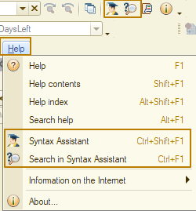
There is also a command Search in Syntax assistant to search for selected text in the syntax assistant, the command is available in the context menu (right-click), on the platform panel or in the Help menu, as well as by hotkey Ctrl + F1:
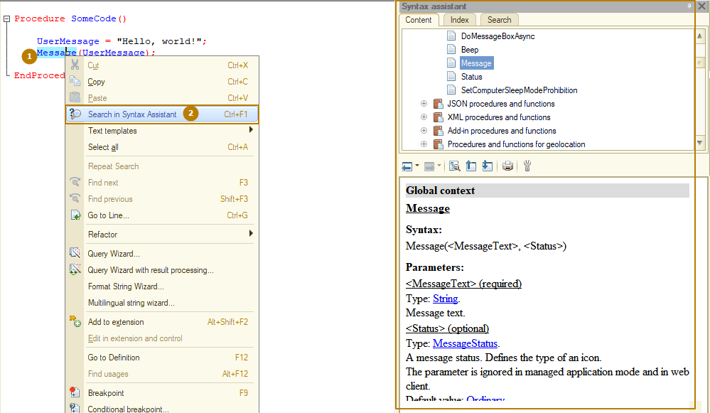
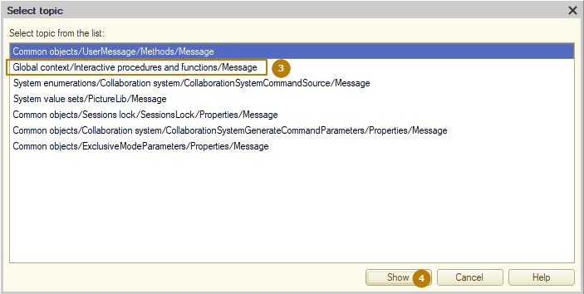

You can search for any information at the “Index” tab. To do this, enter a text in the upper field and double-click (or select and use Enter button) on the one you are interested in in the list of found values. Example for ValueTable: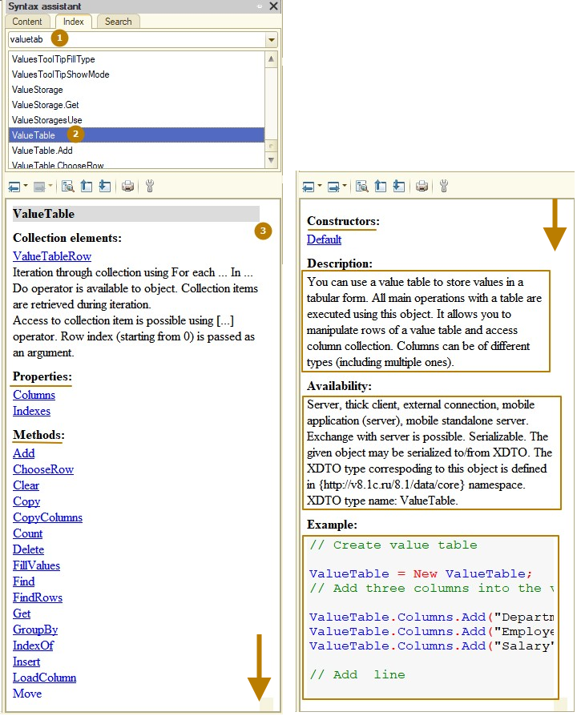
I strongly recommend using this tool more often in order to get acquainted with the built-in 1C language.
Here is an example of how to search for something by some area in the syntax assistant, without knowing what functions exactly a particular type has. I'm working with string data and I want to know if there are any built-in functions that allow me to take only the left 5 characters from a string or how to check whether one string is included in another. To do this, you can expand the "Global context" branch, find the "Functions for working with String type values" branch there, expand it and explore all the functions for strings. This is done similarly for other types.
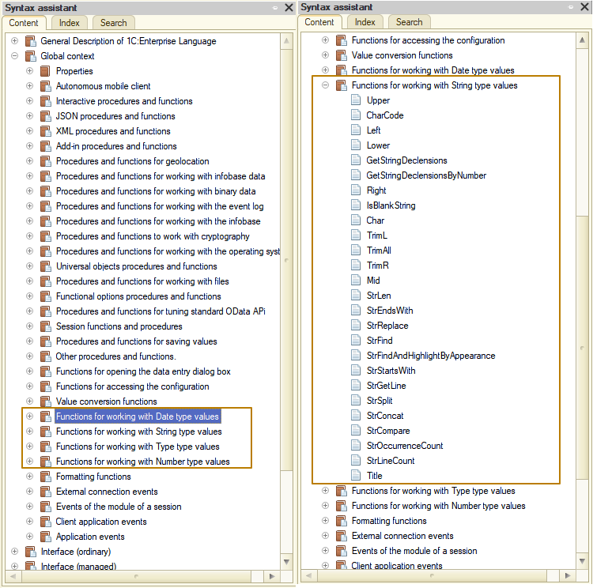
Of course, there are more complex cases, such as finding a form extension for a dynamic list (we'll talk more about what this is later), but as you use the syntax assistant, it will become easier for you to find in it information.
Next, I write “client application form” in the search box and then look for the option I need among the search result.
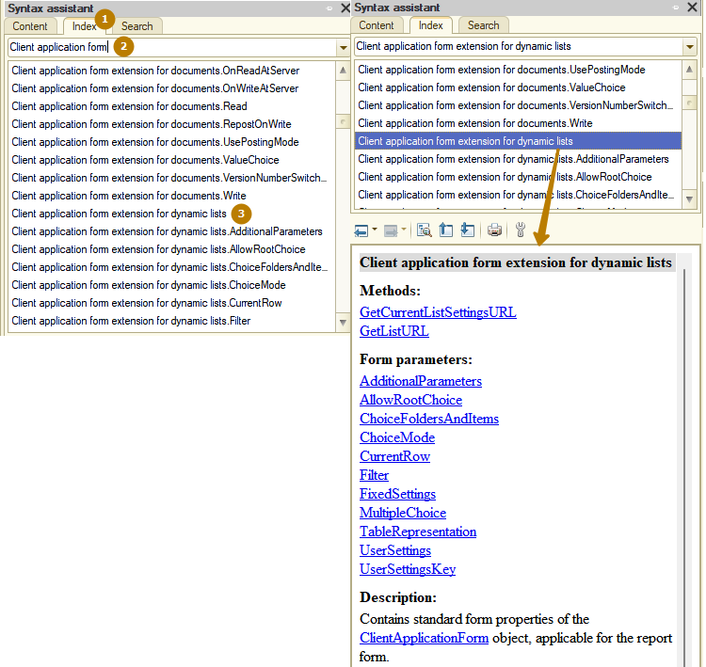
Now I can see in which section this section is located, to do this I click the "Find current element in the tree" button and automatically go to the Content tab, where the section that I was viewing is highlighted. At the top level there is a node that interests me, which I can expand and explore what other features the “Client Application Form” has.
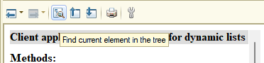
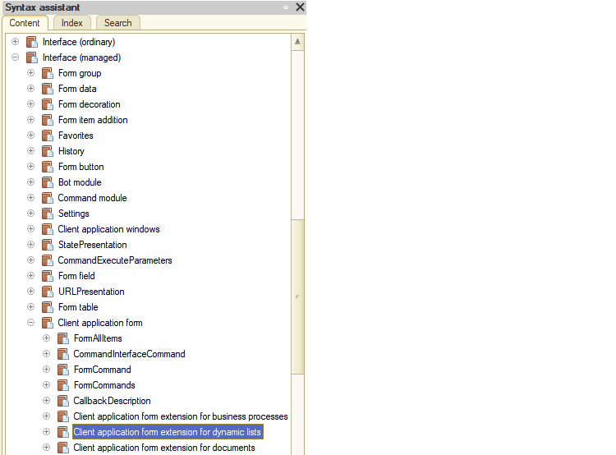
Lesson #6
Operators
Operators in a program module can be divided into two categories: variable declaration operators and executable operators.
Variable declaration operators create variable names that are manipulated by executable operators.
Operators must be separated by semicolons. At the same time, the end of the line does not mean the end of the operator, some operators are usually written on multiple lines (conditions, loops), but the semicolon is placed only at the end of the operator. When describing procedures and functions, a semicolon is not required, you should not use it, this leads to a compilation error.
Example:
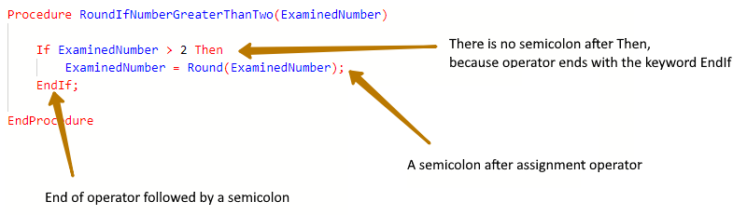
At the same time, it is allowed to write several operators on one line (although it is not recommended to do this, as this makes the code more difficult to read):
Quantity = 10; Price = 50; Amount = Quantity * Price;
If Quantity <> 0 Then Price = Amount / Quantity; Else Price = 0; EndIf;
An expression is a mathematical, logical or string formula consisting of operations that calculate a value. Mathematical and logical expressions may be located to the right of the equality sign in assignment operators or may be a parameter of procedures or functions. Logical expressions can also be conditions in If, While and For control directives. Expressions consist of constants, variables and functions linked with symbols of logical and/or arithmetic operations.
Arithmetic operations
The following types of arithmetic operations are defined in the 1C:Enterprise script:
Name | Expression
Addition | Operand1 + Operand2
Subtraction | Operand1 – Operand2
Multiplication | Operand1 * Operand2
Division | Operand1 / Operand2
Remainder in Division | Operand1 % Operand2
Unary minus | -Operand1
Arithmetic operations have one or two operands which determine operation semantics. Semantics of an operation depend on the first operand. If the second operand type does not match the required one, the value is converted into the required type in compliance with type conversion rules. If the type of the first operand does not match any of the valid types, depending on situation, types may be converted or an execution error may occur.

Operation | Description of Action
Addition is defined for the  following operand types | Number + Number  Date + Number (number of seconds is added to the date)
Subtraction is defined for the  following operand types | Number - Number  Date - Number (number of seconds is subtracted from the date)  Date - Date (result is the difference between two dates in seconds)
Multiplication | Number * Number
Division | Number / Number
Remainder of division (modulo) | Number % Number
Concatenation operations
You can use the concatenation operation (+) to attach one string to another. Length of the resulting string equals the total length of the strings attached. If the data type of the second or subsequent operands does not correspond to the string type, their value is converted to the string type in accordance with type conversion rules.
Example:
FullName = SecondName + " " + FirstName;
Message("Recalculation completed successfully in " + CalculationTime + " seconds");
// CalculationTime is a number

Logical operations
A logical operation compares operands and creates a Boolean value: True or False. There are two types of logical operations: comparison operations and Boolean operations. Comparison operations are used to compare two values. Boolean operations are used for Boolean values and implement Boolean algebra. Boolean operation characters may combine forming compound operations.
Comparison operations
The following comparison operations are defined in the 1C:Enterprise script:
Operation | Operation Expression
Greater | Operand1 > Operand2
Greater or Equal | Operand1 >= Operand2
Equal | Operand1 = Operand2
Not Equal | Operand1 <> Operand2
Less | Operand1 < Operand2
Less or Equal | Operand1 <= Operand2
Comparison operations are defined for the following operand types:
Operation | Operation Expression
Greater | Number > Number  String > String  Date > Date
Greater or Equal | Number >= Number  String >= String  Date >= Date
Less | Number < Number  String < String  Date < Date
Less or Equal | Number <= Number  String <= String  Date <= Date
Equal | Any type = Any type
Not Equal | Any type <> Any type

Boolean operations
The following types of Boolean operations are defined in the 1C:Enterprise script:
AND | Conjunction (Boolean AND)
OR | Disjunction (Boolean OR)
NOT | Logical negation (Boolean negation NOT)
Logical expressions are calculated from left to right. Use round brackets to avoid ambiguity and manage operand sequence.
Order of execution of logical operations:
Level 1 | operands in round brackets
Level 2 | NOT
Level 3 | AND
Level 4 | OR
When a logical expression is calculated, only its required parts are used. For example, if Price <= 0 in the expression
Price > 0 AND CheckSum()
then CheckSum() function is not called, because the first part of the condition is not met, which means that the entire expression will no longer be equal to True.
New
The New operator is used to create values of some types. The type name can be followed by parameters in parentheses if they are defined in the constructors for the given type. The allowed number of parameters and their purpose are specified in the description of the object's constructors.
Examples:
// #1
CreationWithTypeName = New Array;
// #2
ArrayType = Type("Array");
CreationWithTheType = New(Type);

If (condition)
The If operator controls program execution based on the result of one or several logical expressions. The operator can contain any number of operator groups provided in ElsIf - Then pairs.
Examples:
If Quantity = 0 And Amount = 0 Then
Message("Quantity and Amount are required fields.");
EndIf;

If Quantity <> 0 Then
Price = Amount / Quantity;
Else // optional part
Price = 0;
EndIf;

If MonthOfDate >= 1 And MonthOfDate <= 3 Then
Quarter = 1;
ElsIf MonthOfDate >= 4 And MonthOfDate <= 6 Then // optional part
Quarter = 2;
ElsIf MonthOfDate >= 7 And MonthOfDate <= 9 Then // optional part
Quarter = 3;
Else // optional part
Quarter = 4;
EndIf;
Message("It's a quarter #" + Quarter);
In this case, if the value of the variable MonthOfDate = 5, then first the conditional expression MonthOfDate >= 1 And MonthOfDate <= 3 is calculated, then the conditional expression MonthOfDate >= 4 And MonthOfDate <= 6 is calculated, since it is True, then the assignment code Quarter = 2 will be executed, after which the code execution will continue outside the condition block, i.e. conditional expression located in the subsequent ElsIf block will not even be calculated.
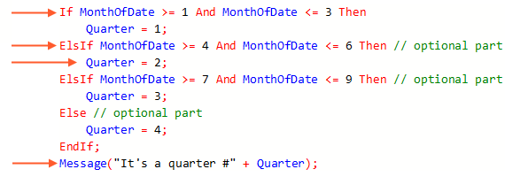
Loops
For
Loop operator For is designed for repetition of statements located inside the Do - EndDo construction. Before the loop starts, the value <Expression 1> is assigned to the variable <Variable name>. The value of <Variable name> is automatically incremented by 1 each time through the loop. The loop is executed as long as the value of variable <Variable name> is less than or equal to the value of <Expression 2>. The loop execution condition is always checked first, before the loop is executed.

For <Variable name> = <Expression 1> To <Expression 2> Do
// Statements
[Break;]
// Statements
[Continue;]
// Statements
EndDo;
Square brackets indicate optional operators that can be used inside the loop. Break is designed to instantly stop the loop bypass. Continue is designed to instantly move to the next step of the loop (sometimes this can lead to the completion of the loop - if after incrementing the expression, it turns out that <Variable name> is greater than <Expression 2>). The statements following it in the body of the loop are not executed at this iteration of a loop.
Example:
// Products is a tabular section with columns "Product" and "Price". Count() is a method of a tabular section, returning count of rows.
For i = 0 To Products.Count() - 1 Do
// Writing a table row found by index to a variable ProductsRow
ProductsRow = Products[i];
// DesiredProduct - is a variable with some searching product
If ProductsRow.Product = DesiredProduct Then
Price = ProductsRow.Price;
Break;
EndIf;
EndDo;
For each
Loop operator For Each is designed to iterate over a collection of values. At each iteration, the next element of the collection is assigned to the variable, and the loop continues until all elements of the collection have been iterated (or until the Break operator is executed).,
For each <Variable name 1> In <Variable name 2> Do
// Statements
[Break;]
// Statements
[Continue;]
// Statements
EndDo;
Example:
Function TotalAmountOfProducts(Products)

Total = 0;
For each ProductRow In Products Do
Total = Total + ProductRow.Amount;
EndDo;

Return Total;
EndFunction
While
Loop operator While is designed for repetition of statements located inside the Do ‑EndDo construction. The loop is executed while the logical expression is True. The loop execution condition is always checked first, before the loop is executed.
While <Logical expression> Do
// Statements
[Break;]
// Statements
[Continue;]
// Statements
EndDo;
Example:
DocumentNumber = "12345";
RequiredLengthOfNumber = 9;
// StrLen() method returns the number of characters in a string
While StrLen(DocumentNumber) < RequiredLengthOfNumber Do
DocumentNumber = "0" + DocumentNumber;
EndDo;
// The value of the DocumentNumber variable is "000012345" now
Collections
Collections of values in 1C are universal objects: Array, ValueList, ValueTable, ValueTree, Structure, Map.
Array
Array is a collection of elements following one after another, which can be accessed using the array index. Elements can be of any type, including the Array type. Each element in an array has a unique number, which is called an Index. An index can be used to access a given element. All elements in the array are ordered, i.e. the first element has an index 0, the second element has an index 1, and so on.
Example:
Array = New Array;

Array.Add("January"); // Index = 0
Array.Add("February"); // Index = 1
Array.Add("March"); // Index = 2
Array.Add("April"); // Index = 3
Array.Add("May"); //...
Array.Add("June");
Array.Add("July");
Array.Add("August");
Array.Add("September");
Array.Add("October");
Array.Add("November");
Array.Add("December");

NumberOfMonth = 4;

Month = Array.Get(NumberOfMonth - 1); // Month = "April"

ValueList
ValueList is a universal collection of values, which, in fact, is a one-dimensional dynamic array created within the 1C platform to solve some interface tasks. Unlike a simple array, whose elements can be of arbitrary types, in a list of values each element has the special type ValueListItem. ValueListItem can store the following data: value itself (of any type), value representation (string type), check mark (boolean type), and the picture (picture type).
Example:
ValueList = New ValueList;

ValueList.Add(1, "January"); // Index = 0
ValueList.Add(2, "February"); // Index = 1
ValueList.Add(3, "March"); // Index = 2
ValueList.Add(4, "April"); // Index = 3
ValueList.Add(5, "May"); //...
ValueList.Add(6, "June");
ValueList.Add(7, "July");
ValueList.Add(8, "August");
ValueList.Add(9, "September");
ValueList.Add(10, "October");
ValueList.Add(11, "November");
ValueList.Add(12, "December");

NumberOfMonth = 4;

Month = ValueList.FindByValue(NumberOfMonth);
ValueTable
ValueTable is an object that is not saved in the database and allows to build dynamic sets of values and manipulate them (add, edit, delete elements, sort). It can be filled with values of any type, i.e. in one table, the types of stored values can be different. One example of the use of this object is the organization of the presentation in a list form of catalog elements selected according to a complex algorithm.
This collection allows us to manipulate the rows of the table of values and provides access to the collection of columns. As we said, columns can be of different types (a column can have a composite type, i.e. it can have several types). ValueTable can be sorted, copied, also it allows to unload and load values.
Example:
ValueTable = New ValueTable;

ValueTable.Columns.Add("FullName", New TypeDescription("String"));
// If you don't specify a type, you can write a value of any type to the column.
ValueTable.Columns.Add("Seniority"); // years of work experience
ValueTable.Columns.Add("DateOfBirth",
New TypeDescription("Date",,,,, New DateQualifiers(DateFractions.Date)));

NewRow = ValueTable.Add();

NewRow.FullName = "John Doe";
NewRow.DateOfBirth = Date(1970, 12, 31);
NewRow.Seniority = 8; // Number

NewRow = ValueTable.Add();

NewRow.FullName = "Jane Doe";
NewRow.DateOfBirth = Date(1985, 1, 5);
NewRow.Seniority = "None"; // String

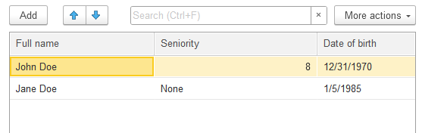
ValueTree
ValueTree is a generic collection of values in which data can be arranged hierarchically in a tree. In essence, a value tree is a table of values, where rows can have subordinate rows. One row of the value tree can have several subordinate rows, but at the same time it can have only one row to which it is subordinate - the parent row, or no parent at all. A row without a parent is the top-level row, or the first row.
Example:
ValueTree = New ValueTree;
ValueTree.Columns.Add("City", New TypeDescription("String"));
ValueTree.Columns.Add("Population", New TypeDescription("Number"));

NewCountryRow = ValueTree.Rows.Add(); // top-level row
NewCountryRow.City = "UK";
NewCountryRow.Population = 68138484;

NewCountryRow = NewCountryRow.Rows.Add(); // second level row
NewCountryRow.City = "England";
NewCountryRow.Population = 56489800;

NewRow = NewCountryRow.Rows.Add(); // third level row
NewRow.City = "London";
NewRow.Population = 8799800;

NewRow = NewCountryRow.Rows.Add();
NewRow.City = "Birmingham";
NewRow.Population = 2293099;

NewCountryRow = ValueTree.Rows.Add();
NewCountryRow.City = "France";
NewCountryRow.Population = 68042591;

NewRow = NewCountryRow.Rows.Add();
NewRow.City = "Paris";
NewRow.Population = 2229621;

NewRow = NewCountryRow.Rows.Add();
NewRow.City = "Marseille";
NewRow.Population = 855393;
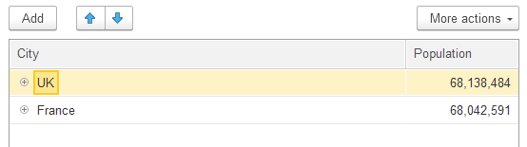
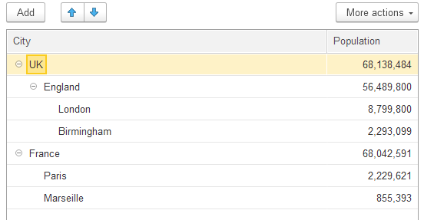
Structure
Structure is a collection of some values associated with a key. This key-value association is called KeyAndValue. The structure key is unique within the structure. Moreover, the values of the structure can be accessed as properties of the object, using the name of the key.
Example:
// 1. Empty structure for insertion of keys and values
Structure = New Structure;

Structure.Insert("FirstName", "John");
Structure.Insert("SecondName", "Doe");

// 2. In this case both keys have Undefined value after initialization
Structure = New Structure("FirstName, SecondName");
// a) usage of Insert method
Structure.Insert("FirstName", "John");
// b) usage of access as a property
Structure.FirstName = "John";
// c) usage with square brackets
Structure["SecondName"] = "Doe";

// 3. Initialization with keys and values
Structure = New Structure("FirstName, SecondName", "John", "Doe");
I draw your attention to the fact that the KeyAndValue binding is unique, so if you insert different values for the same key twice, then there will still be one Key and Value binding in the structure, and the value will be taken from the last method.
Example:
Structure = New Structure;

Structure.Insert("FirstName", "John");
Structure.Insert("FirstName", 752);
// This structure contains one Key “FirstName” with the value 752
If you specify the name of a key that does not exist in this structure, the program will generate an error. But there is a method of the Structure, which allows to check for the presence of a key in the structure and even assign the value of the key to the specified variable. This method is Property(). It is a function and it returns True if the specified key exists and False if the specified key does not exist.
Example:
// Option 1
If Structure.Property("FirstName") Then
FirstName = Structure.FirstName;
EndIf;

// Option 2
FirstName = Undefined;
Structure.Property("FirstName", FirstName);
// In this case if Structure contains "FirstName" key, then its value will be assigned to FirstName variable (as if the code FirstName = Structure.FirstName was executed), otherwise method will return Undefined value to the FirstName variable
Map
Map is also a collection of key and value pairs. But unlike a Structure, a value of any type can be used as a key (String, Number, Date, Reference and so on). To get a value by a specific key, you need to access it not as a property of an object, but with square brackets, or get it using the Get() method.
Map is an indexed collection where getting a value is as fast as possible.
Example:
// 1. setting values
Map = New Map;
// a)
Map.Insert(10, "Even");
// b)
Map[11] = "Odd";

For Each KeyAndValue In Map Do
Message("Key: " + KeyAndValue.Key + ", Value: " + KeyAndValue.Value);
EndDo;

// 2. getting values
Map = New Map;
Map[True] = "True";

// a)
ValueOfTrueKey = Map[True];
// b) If Map doesn't contain such Key, it returns Undefined
ValueOfFalseKey = Map.Get(False);

Message(ValueOfTrueKey = "True");
// checking if the value is Undefined with a message
Message(ValueOfFalseKey = Undefined);
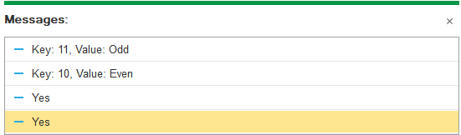
Note that the Map, like the Structure, does not keep the order of added keys and values.

